SAGE GEOSYSTEMS - OVERVIEW

ENERGY STORAGE FACILITY (EarthStore™)
JANUARY 22, 2024

Corporate Overview

Sage Geosystems Inc. (Sage) is a pre-revenue start-up firm founded in 2020 with energy storage and geothermal baseload technologies deep in the earth. Sage is a Delaware corporation located at 515 W Greens Road, Suite 300, Houston, Texas, USA 77067. We are not a subsidiary of another corporation, nor do we currently have any subsidiaries. Additional information is available at our website at www.sagegeosystems.com.

While Sage has a strong development pipeline, including projects for the Department of Defense, we are pre-revenue and do not have projects delivered to operation yet. However, the Sage executive team has over 100 combined years in the oil & gas industry, with experience delivering major projects including Deepwater, Arctic, and Unconventional shales:

- Cindy Taff (U.S. citizen) has over 35 years in the oil and gas industry, most recently as VP of Shell’s global Unconventional Wells & Logistics operations. She led a team of over 350 Shell staff and 1200 contractors across five countries, accountable for an annual spend of
$1 billion. Over a 5-year period, she led her team to systematically reduce costs by > 50% while scope (lateral lengths and frac intensity) significantly increased. She has a BSc degree in Mechanical Engineering. Cindy is the CEO of Sage Geosystems.

- Dr. Lev M. Ring (U.S. citizen) has over 25 years of oil field experience managing engineering and R&D teams in drilling and well construction. Lev holds more than 120 patents in the areas of drilling, well construction, and well completion. He has a PhD degree in Physics and began his career as an aerospace engineer prior to joining the oil and gas industry. Lev is a co-founder of and currently the President of Sage Geosystems.

- R. Lance Cook (U.S. citizen) has over 40 years in the oil and gas industry, most recently as VP of Global Wells Technology and Chief Scientist of Wells at Shell. He led Shell’s Deepwater technology development and two Shell joint venture technology efforts in expandable casing and well manufacturing. He has a BSc degree in Petroleum Engineering. Lance holds over 120 U.S. patents and is a co-founder of and currently the CTO of Sage Geosystems.
Sage’s energy storage technology is mechanical with the resource being subsurface pumped storage hydropower. The technology is at a Technology Readiness Level TRL-7, with a first commercial energy storage facility planned for Q4 2024 to bring it to TRL-8. The round-trip efficiency (RTE) is 70-75% AC-to-AC with a duration range of 2 to 24+ hours and an energy footprint of 80 MWh/acre.

Sage’s underground, pumped-hydro-like mechanical energy storage system utilizes deep geologic structures by creating a vertical fracture system in low-permeability formations. Charging involves pumping water from a surface storage facility through the wellbore into the fracture, which acts as an artificial underground reservoir, and building pressure above hydrostatic by inflating the fracture system with a volume of water. Discharging involves turning off the pump and allowing the fracture to partially deflate and to push a portion of the water back up the wellbore to the surface, where it drives a Pelton turbine-generator. Known as EarthStore™, Sage operates these vertical fractures between fracture opening and fracture extension pressure, meaning there is always a volume of water in the fracture, and we cycle about 10% of this volume to maintain a high RTE. This technology is very flexible in that, when required, additional water can be pulled from the fracture to generate electricity with the only impact being a lower RTE. In addition, this energy storage technology has a wide duration range (i.e., from 3- to 24+-hours), with the same well and plant configuration.

Sage has also developed a variant of the EarthStore energy storage system called Battery+™, in which the stored subsurface water harvests natural geothermal heat from the surrounding formation which is used to generate electricity through a binary cycle power plant, using either an off-the-shelf Organic Rankine Cycle (ORC) or Sage’s proprietary supercritical CO2 (sCO2) power system. In this scenario, both the heat and pressure energy of the water contribute to the net electricity generation at the surface. For Battery+, a formation temperature between 150-250°C is required and for every 1MW stored, 2MW are returned to surface through storage and geothermal generation. Sage accomplishes geothermal baseload power generation with multiple deep wells drilled into these hot formations with temperatures between 150-250°C by cycling the water at the surface between wells.

In late 2021, Sage re-entered an existing gas exploration well in Starr County, Texas which was drilled in 2008. We demonstrated our downward-oriented gravity fracturing technology in this well by creating a 3,200-foot vertical fracture between 7,920 feet and 11,120 feet. We then spent the next four months performing circulation and pump-in/flowback testing, resulting in our Geopressured Geothermal System (GGS) technology for hot dry rock geothermal, also referred to huff-and-puff in the oil & gas industry. It was during this testing that we realized we had the perfect energy storage solution. Sage shut-in the well in April 2022 but returned in February 2023 to perform a commercial pilot demonstration of our subsurface pumped storage hydro technology. Over a 5-week period from February 2023 to April 2023, we pumped and stored water in the reservoir and were able to demonstrate both long-duration and load-following energy storage capabilities. For long-duration, early testing found that pumping 5,000 barrels of water into the well/reservoir system could, upon discharge, produce 200 kW of electricity for 5 hours. Later testing with a larger water volume (20,000 barrels) extended the duration of the 200-kW output case to 18 hours. For load-following, using an injection volume of 20,000 barrels enabled power output at 650 kW for a 2-hour duration. In a “high output” test, 1 MW of power was generated for 30 minutes. The output capacity during this testing was limited only by the small diameter of oil and gas rental piping used at surface. Another test cycle in this commercial pilot attained a charging time of 7 hours and discharging duration of 17 hours, which demonstrated that we can generate baseload power when paired with solar. Sage Geosystems worked with the University of Texas Bureau of Economic Geology, an independent organization, to install four seismic monitoring stations around the Starr County test site to measure induced seismicity. As expected, none was detected either during hydraulic rock fracturing or subsequent water pumping/flowback operations. This data is publicly available on the internet.

Financing Overview

Sage has raised $25 million in seed funding since early 2021, including a $1 million non-dilutive grant from the U.S. Air Force. Sage closed on December 21, 2023, the first $16 million of our $30 million Series A round with Chesapeake (CHK) as our lead investor. This $16 million enables us to build our first full-scale 3MW subsurface pumped storage hydro facility with a planned Commercial Operation Date (COD) of Q4 2024. Sage is working with Evercore (broker) to raise the remaining $14 million for our Series A.

Project Schedule

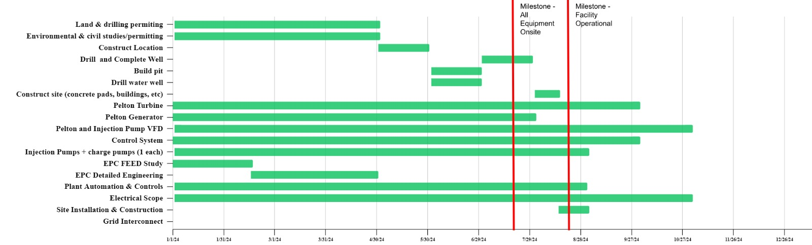
Included below is a Gantt chart showing the details of our first full-scale 3MW subsurface pumped storage hydro facility planned to be built and commissioned by Q4 2024.

EarthStore™ Energy Storage at Scale

With a per well energy storage capacity of 3MW, Sage’s initial design sizes the Pelton turbine at 3MW for a modular per well installation. For the 30MW capacity offer for example, we would drill ten wells and perform a techno-economic evaluation on whether to build larger Pelton turbine(s) or maintain the per well Pelton turbine approach. The footprint for the 10-well, 30MW capacity energy storage facility would be less than 5 acres, with an additional 5 acres needed for surface water storage.

The at-scale artist rendering below shows a 10-well, 30MW facility with the wells spaced 10 feet apart, enabling cost-effective drilling via manufacturing mode using an off-the-shelf “walking” drilling rig from the oil and gas industry.
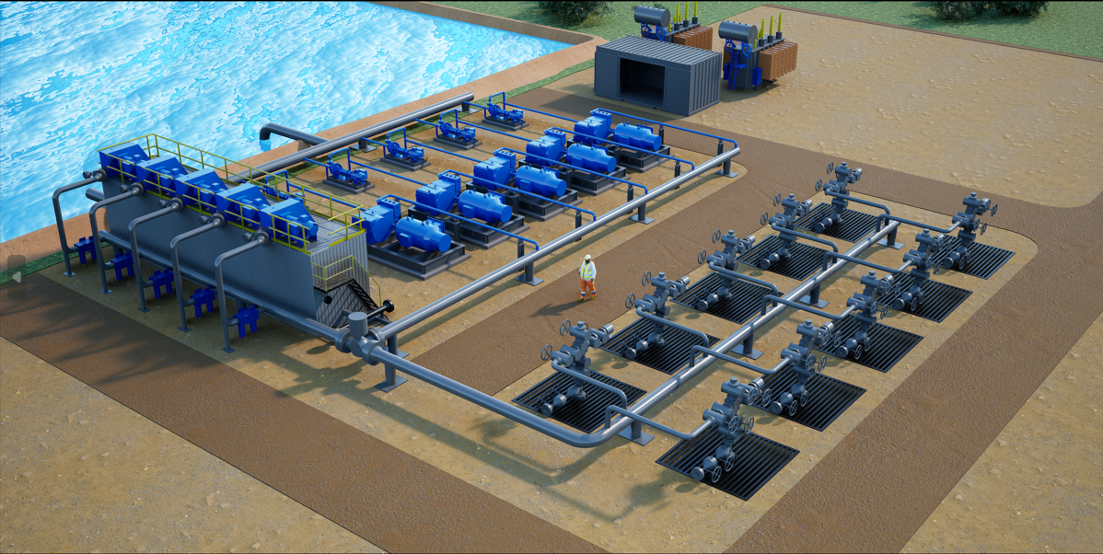

Sage 30MW Energy Storage Facility

